1448. Count Good Nodes in Binary Tree
Medium

Given a binary tree root, a node X in the tree is named good if in the path from root to X there are no nodes with a value greater than X.
Return the number of good nodes in the binary tree.

Example 1:
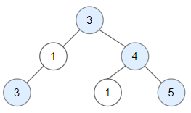
Input: root = [3,1,4,3,null,1,5]
Output: 4
Explanation: Nodes in blue are good.
Root Node (3) is always a good node.
Node 4 -> (3,4) is the maximum value in the path starting from the root.
Node 5 -> (3,4,5) is the maximum value in the path
Node 3 -> (3,1,3) is the maximum value in the path.
Example 2:
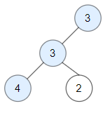
Input: root = [3,3,null,4,2]
Output: 3
Explanation: Node 2 -> (3, 3, 2) is not good, because "3" is higher than it.
Example 3:
Input: root = [1]
Output: 1
Explanation: Root is considered as good.

Constraints:
- The number of nodes in the binary tree is in the range [1, 10^5].
- Each node's value is between [-10^4, 10^4].

